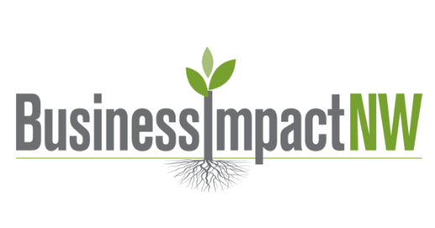

Advanced Marketing Strategy & Channel Planner

This planner helps small business owners focus their marketing by clearly identifying the right customer, the right channels, and the right message—so you’re not wasting time or money on tactics that don’t fit. It’s useful because it forces you to prioritize one main channel and one supporting channel based on speed, effort, and confidence, rather than trying to do everything at once. Use it to create a realistic 90-day marketing plan that aligns with your capacity and drives measurable results instead of vanity metrics.
(Post–Market Research)

1. BUSINESS CONTEXT
Business Name:
Stage of Business: ☐ Idea ☐ New ☐ Operating ☐ Scaling
Primary Offer (be specific):

Price Point: ☐ Under $50 ☐ $50–$250 ☐ $250–$1,000 ☐ $1,000+
Buying Decision Type:
☐ Impulse
☐ Considered (needs trust)
☐ High-trust / High-risk

2. TARGET CUSTOMER (FROM MARKET RESEARCH)
Primary Customer Description:

Top 1–2 Problems They Are Actively Trying to Solve:

What Triggers Them to Look for a Solution?
☐ Pain / urgency
☐ Life change
☐ Recommendation
☐ Seasonal / timing-based
☐ Curiosity / aspiration
Where They Already Spend Time (be specific):

3. MARKETING GOAL (NEXT 90 DAYS)
Choose one primary goal:
☐ Awareness (people know we exist)
☐ Leads / inquiries
☐ First sales
☐ Repeat customers
☐ Authority / credibility
Success looks like:

4. CHANNEL SPEED LEGEND (INCLUDE ON ALL PLANNERS)
Fast channels reach people who already trust you or are actively looking for a solution.
Results usually show up in days or weeks.
Slow channels build awareness and trust before people are ready to buy.
Results usually take months.
Neither is better — they serve different purposes.

5. CHANNEL EVALUATION & PRIORITIZATION
Use this table to eliminate, not expand.
Channel | Customer Is Here? | Speed | Effort | Cost | Confidence | Use Now?
In-person networking | ☐ Yes ☐ No | Fast | Med | $ | High / Med / Low | ☐
Referrals | ☐ Yes ☐ No | Fast | Low | $ | High / Med / Low | ☐
Partnerships | ☐ Yes ☐ No | Fast | Med | $ | High / Med / Low | ☐
Email | ☐ Yes ☐ No | Mixed | Med | $ | High / Med / Low | ☐
Instagram | ☐ Yes ☐ No | Slow | High | $ | High / Med / Low | ☐
Facebook | ☐ Yes ☐ No | Mixed | Med | $ | High / Med / Low | ☐
Google Search / SEO | ☐ Yes ☐ No | Slow | High | $$ | High / Med / Low | ☐
Paid Ads | ☐ Yes ☐ No | Fast | Med | $$ | High / Med / Low | ☐
Events / Pop-ups | ☐ Yes ☐ No | Fast | High | $$ | High / Med / Low | ☐

6. CHANNEL SELECTION (FOCUS)
Primary Channel (Main Effort):

Why this channel fits this customer right now:

Supporting Channel (Backup / Reinforcement):

Why this channel supports the primary one:

Rule:
One primary channel. One supporting channel.
Everything else is deferred.

7. MESSAGE STRATEGY (CHANNEL-AGNOSTIC)
Core Problem We Lead With:

Simple Promise We Make:

Proof We Can Show (examples, experience, results):

Primary Call to Action:
☐ Book a call
☐ Visit website
☐ Buy now
☐ Attend event
☐ Reply / DM

8. EXECUTION PLAN (REALISTIC)
Primary Channel Activities:
- Activity: ____________________________________
- Frequency: _________________________________
- Time per week: ______________________________
Supporting Channel Activities:
- Activity: ____________________________________
- Frequency: _________________________________

9. METRICS THAT MATTER (NO VANITY METRICS)
Channel | Metric | Target
Primary Channel | Leads / Sales
Supporting Channel | Engagement / Responses
Overall | Revenue or booked calls

10. REVIEW & ADJUST (30–90 DAYS)
What’s working:

What’s not:

What to stop, start, or change:

FINAL CHECK
☐ Channels chosen based on customer behavior
☐ Speed understood (fast vs slow)
☐ Effort matches capacity
☐ Metrics are actionable

